Chris Levitt – Apple Farming in Kent
Chris Levitt is a local apple farmer who has a genuine passion for fruit farming, particularly apples. Before concentrating on farming, Chris spent ten years working as an agronomist, giving him considerable knowledge of crops, soils, plant health and the factors affecting successful fruit production. His talk provided a fascinating journey through the history of apple growing and explained why Kent became so closely associated with orchards and fruit production.
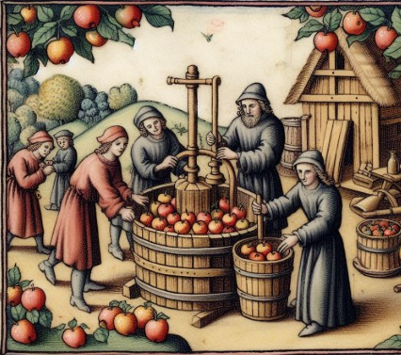
Chris began by taking us back to the origins of the apple. The ancestors of many of the apples we recognise today can be traced to Central Asia, particularly Kazakhstan, thousands of years ago. Apples gradually travelled westwards along trading routes before the Romans brought cultivated varieties to Britain around AD 50. Apples were valued not only as food but also for making cider.

The development of apple growing continued after the arrival of Christianity in Britain. From around AD 597, monasteries became important centres for horticulture. Monks cultivated and developed fruit varieties within their gardens and orchards, with cider continuing to be an important product. The Norman period brought further improvements as additional varieties and growing knowledge arrived from continental Europe.
By the thirteenth century, apples were becoming increasingly established. Pippin varieties were known by around 1204, while the Costard cooking apple appeared later in the century. Chris explained that the Costard also gave rise to the word “costermonger”, originally referring to a seller of Costard apples.
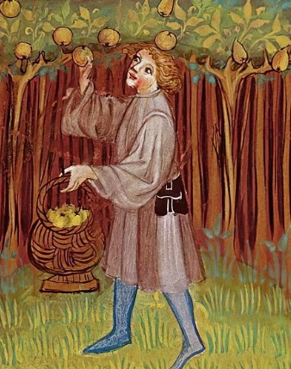
During the Middle Ages, orchards became better suited to the English climate than vineyards and consequently became increasingly important. Progress was not continuous, however. The Black Death caused an enormous reduction in the available workforce, and the later Wars of the Roses brought further disruption.

Apple growing received another boost during the reign of Henry VIII. His royal fruiterer, Richard Harris, travelled to France and returned with new fruit varieties. Harris subsequently established a large orchard of around 105 acres at Teynham in Kent. Fruit also became increasingly fashionable in wealthy households, where apples began to be served at the end of meals as dessert fruit.
Chris also described the colourful tradition of orchard wassailing. This involved communities gathering in the orchard around the cider crop, often focusing their celebrations on one of the best trees. People would sing and dance around the tree and make considerable noise, sometimes including firing shotguns, in a tradition intended to drive away evil spirits and encourage a healthy and productive crop in the coming year.
By the eighteenth century, however, agricultural fashions were changing. Kent increasingly turned towards hop production as beer became more widely consumed and affordable. Apples therefore faced competition for valuable agricultural land.
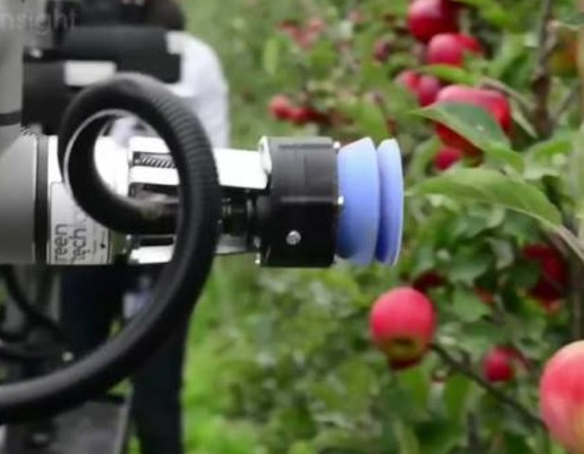
The nineteenth century brought some varieties that remain familiar today. The Bramley cooking apple originated in Nottinghamshire from a tree grown from a pip planted in 1809. Cox’s Orange Pippin followed during the nineteenth century and became one of Britain's best-known dessert apples. Despite such developments, commercial apple production faced periods when profitability was difficult because of economic conditions, imports and the costs associated with production and processing.

Chris explained that the last 125 years have probably seen more technological and scientific change in fruit growing than any previous period. An important development for Kent was the establishment of the East Malling Research Station. Scientific research into genetics, soils and rootstocks transformed growers’ understanding of orchards.
The National Fruit Collection was established in 1922 and eventually moved to Brogdale Farm, near Faversham, during the 1950s. Today the collection contains thousands of different fruit varieties, including an extraordinary range of apples and pears. Research into rootstocks was particularly significant commercially. By controlling the vigour and ultimate size of trees, growers could produce much smaller trees planted more closely together. This made orchards easier to manage and harvest while allowing far greater yields from a given area of land.Kent’s orchards also became part of the county’s cultural identity. Blossom tours became extremely popular, with families driving through the Kent countryside specifically to see the spectacular displays of apple, pear and cherry blossom.
The modern apple industry, however, has faced increasing competition. Chris made the interesting observation that during the 1970s even crisps began competing with apples for their traditional place as a convenient snack. Overseas fruit provided an even greater challenge. French apples marketed under the Le Crunch brand and varieties such as Golden Delicious became increasingly visible, while the expansion of worldwide imports meant consumers could choose imported apples throughout much of the year.
As international competition increased, Kent’s orchard acreage declined considerably. British growers also faced a natural disadvantage compared with important fruit-growing regions in countries such as France and Italy: the amount and quality of sunlight available. Light has a major influence on fruit quality, colour and yield, making it difficult for Kent growers to compete simply by producing ever greater quantities.
These financial pressures have helped transform the structure of the industry. Farms have amalgamated into much larger businesses capable of investing in expensive machinery and technology. Mechanisation has reduced the number of people required for jobs that once depended heavily on pickers and packhouse workers. More recently, drones, robotics and increasingly sophisticated technology have begun to find a place in modern orchards.
Chris’s talk demonstrated that the history of Kentish apple farming is really a story of constant adaptation. From Roman varieties and medieval monasteries to Henry VIII’s orchards, wassailing, scientific research, dwarfing rootstocks, international imports and modern robotics, growers have continually had to respond to changing circumstances.
Perhaps the most interesting point is that this story is still developing. Climate change presents both challenges and potential opportunities for Kent’s growers. After thousands of years of apple cultivation and centuries of orchards being an important feature of the Kent countryside, there are clearly many more corners still to be turned in the story of apple production in Kent.
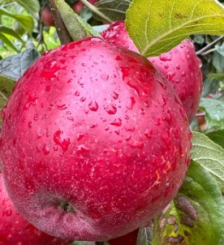
Chris has donated his entire fee to the Motor Neurone Disease Association.

