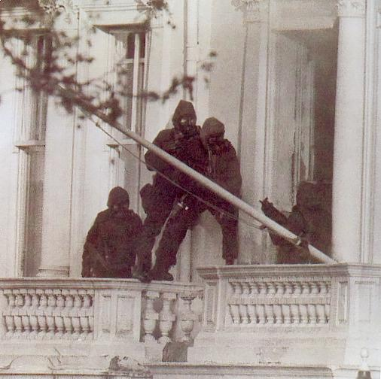
The Embassy Siege of 1980 Re-visited

On Thursday 19th September Guy Bartlett returned to Matfield Village Hall to give a talk on how the SAS raid on the Iranian Embassy in London in 1980 revealing fresh information recently obtained by one of the SAS officers that took part.

Until that time, the SAS was almost completely unknown to the general British public. But that was about to change.

Day 1

11.20 on 30 April, six armed members of the Democratic Revolutionary Front for the Liberation of Arabistan (DRFLA) led by man known as Salim storm the Iranian Embassy on Princes Gate in South Kensington, taking 26 people hostage, overpowering the diplomatic protection officer PC Trevor Lock. The group was fighting for that region’s autonomy and the release of 91 rebels.
11.44 A retired SAS officer who happened to be walking his dog near by, overheard on his radio what was happening and immedaitely reported it to his old SAS boss.
11.48 The SAS Special Projects call Red & Blue troop to action.
3pm The government convenes an emergency committee meeting of COBR, which includes The PM, Margaret Thatcher, Home Secretary Willie Whitelaw, Deputy Assitant Commissioner Dellows & Brigadier Peter de la Billière, Director of the SAS.
Mrs Thatcher declares “No terrorist will leave the UK under any circumstance”
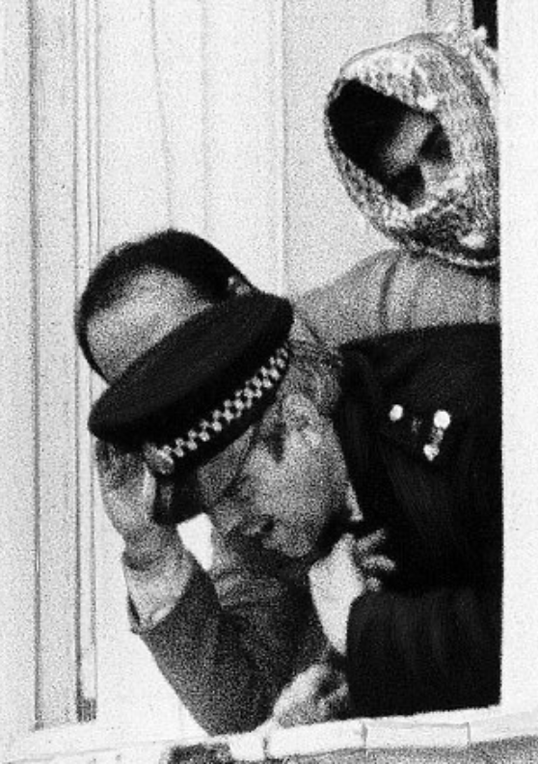
Day 2
SAS arrive at Regents Park Barracks and form an IAP - Immediate Acrtion Plan. Using Blue Prints and models of each floor of the Embassy.
There is now a requirement to drop microphones down the chimneys and through the walls from next door. To mask this activity and more, Heathrow are ordered to divert all aircraft over central London and British Gas dig up near by roads using jackhammers.
Two sick hostages are released. A pregnant woman and Chris Cramer, a BBC Staff member who aquires a serious stomach illness. They provide intelligence to the police, who continue to negotiate with the terrorists. The gunmen demand safe passage out of Britain, communciating through a second floor window using PC Lock as a shield from any sniper.

Day 3
Police send in a field telephone and food from which they gain valuable finger prints. The phone is also fixed so that even when hung up it is still listening in.

Days 4 & 5
Terrorists getting mentally and physically exhausted. They demand that the BBC broadcast a statement. The police agree to this in retrurn for the release of two more hostages. A woman was selected and also a man who the hostages selected due to his nightly snoring.
SAS prepare ropes from the accessed roof as well as discovering an unlocked skylight. They are also informed by the caretaker that the front windows and doors had recently been replace by bomb-proof materials.
Day 6
The BBC broadcast the Terrorists sprawling statement although the gunmen are angry about their negative portrayal.
1pm the gunmen threaten to kill a hostage, if an Arab ambassador is not provided for them to talk to. The Iranian cultural attaché, Abbas Lavasani, offers himself as a martyr to the the Islamic revolution. At 1.45pm, three shots are heard.
3.50pm the government orders Colonel Rose, commanding the SAS to prepare an assault. By 5pm, two teams are in position. It is still unclear at this point whether a hostage has been killed or not.

7pm, the body of Lavasani is pushed out of the Embassy. Fearing for the remianing hostages' lives, Margaret Thatcher orders an SAS assault.

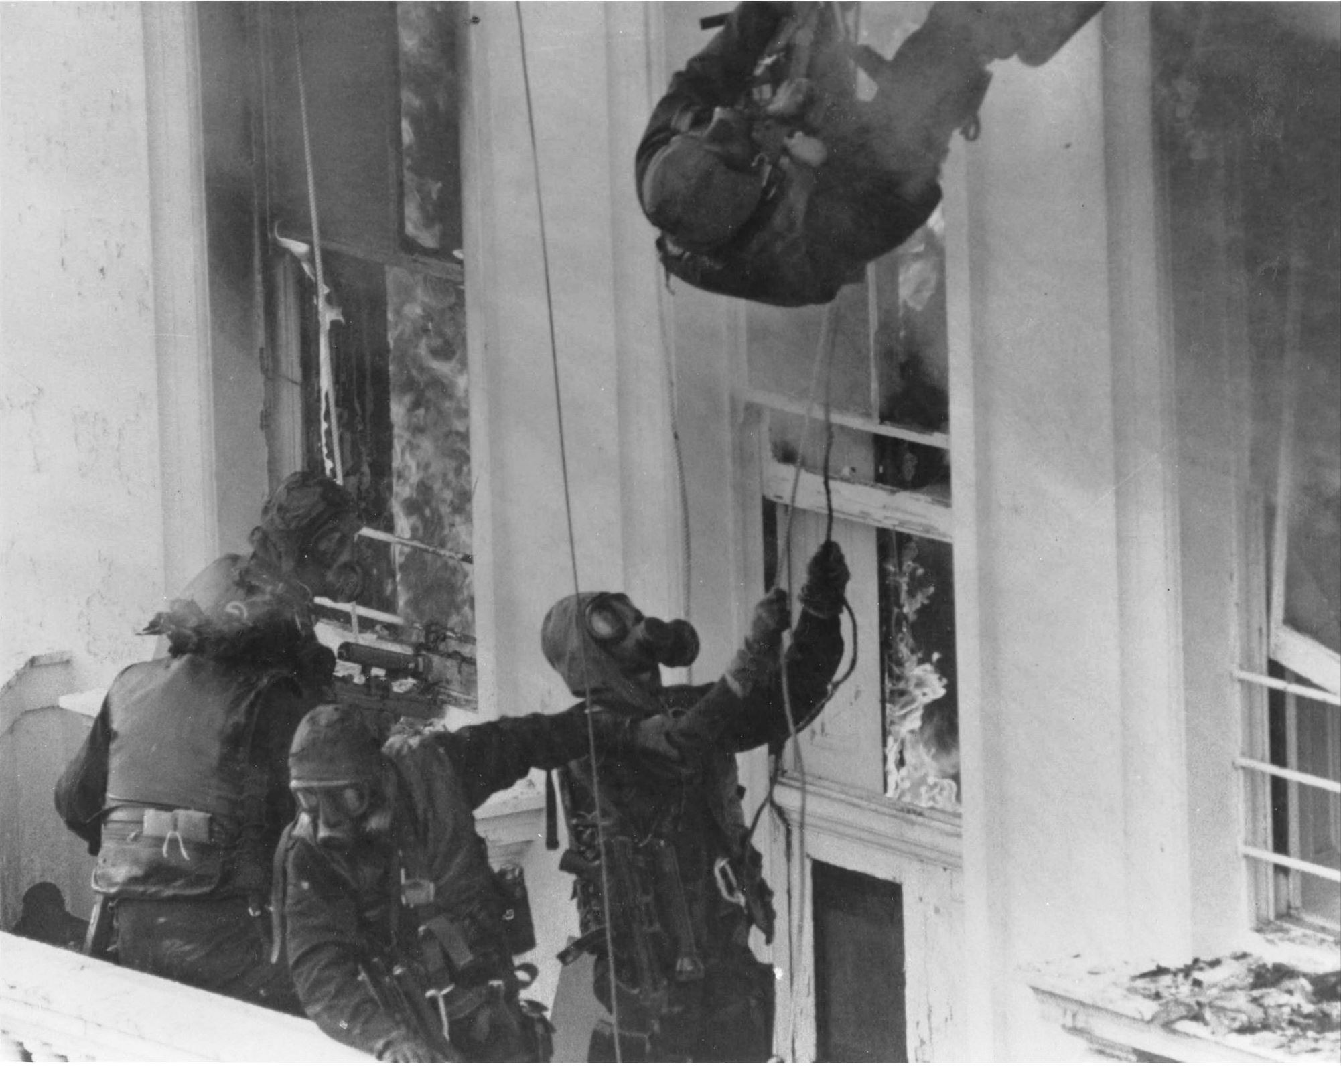
At 7.07pm. Dellows signs a hand written note that hands over control to Rose.

On the roof, one team abseils down the rear of the building, but a soldier gets entangled in ropes and a window is broken. The gunmen realise an assault is beginning.

With their colleague dangling from his ropes, the team at the rear ground floor cannot use their explosives. They instead smash their way in with sledgehammers.

At the front, another team crosses from an adjacent balcony and detonates frame charges against the armoured windows. They throw in stun grenades and enter the building, which is soon ablaze.

On the first floor, PC Lock wrestles with Salim. Ordered to roll away by intruding SAS, Salim is shot. Elsewhere in the building, one hostage is killed and two others injured by terrorists, before being eliminated.

The SAS evacuate the hostages down a staircase, but another gunman - armed with a grenade - conceals himself amongst them. The SAS spot him, consider the threat he is posing to the hostages, and shoot him.

The hostages are led outside to lie down with hands bound. The last remaining gunman, Fowzi Nejad, is discovered hiding amongst them. He is quickly removed and arrested.

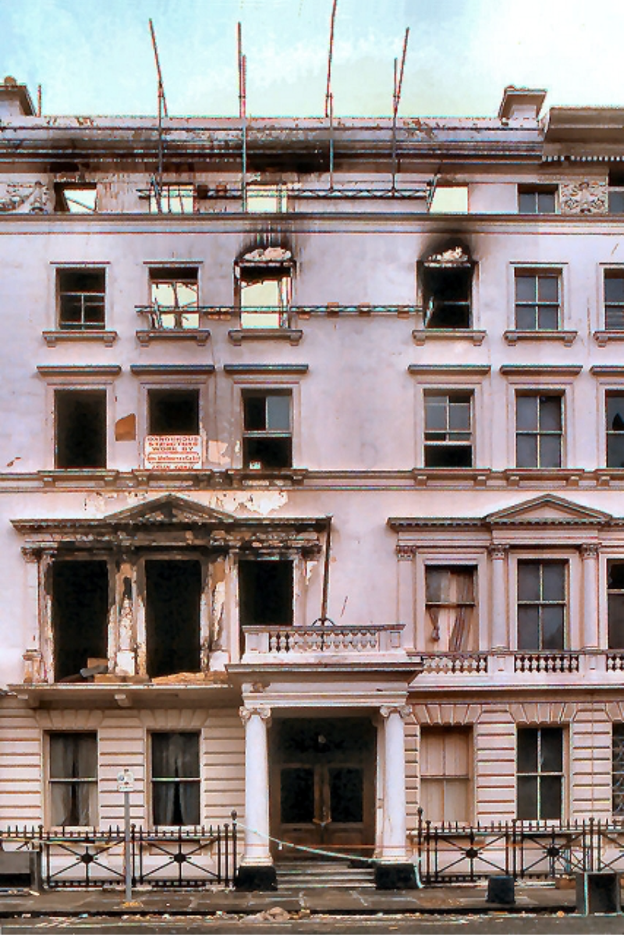
7.40pm The assault ends. Control of the situation and area passes back to the police.

Five terrorists were eliminated during the raid, The sixth, Nejad, served 27 years in jail in Britain. On his release in 2008 he could not be deported under human-rights law for fear of his life in Iran and now lives in Peckham under a new idenity. Just one hostage was killed and two others wounded by the terrorists during the raid. 17 hostages were realesed alive and well.

The SAS raid, televised live around the world on a bank holiday evening, became a defining moment in British history.

Ted Fisher
Chairman
brenchleymatfieldhistsoc.com

